Data Representation

Lab 05.2: Flask: intro to web server

Lecturer: Andrew Beatty

Get a web server to run :

* Create a simple app-server with flask
* Serve static web pages
* Get pre-written REST-server to run (and test it with curl)
* The server serves out a RESTfull api that performs CRUD operations on cars

|  |  |  |  |  |
| --- | --- | --- | --- | --- |
| Action | Method | URL | Sample params | Sample return |
| Get all | GET | /cars | none | {  cars:[  {…},{…},{…}  ]  } |
| Find by id | GET | /cars/*reg* | none | {car:  {  "reg":"12 D 1234",  "make":"Fiat",  "model":"Punto",  "price":3000  }  } |
| Create | POST | /cars | {  "reg":"12 D 1234",  "make":"Fiat",  "model":"Punto",  "price":3000  } | {  "reg":"12 D 1234",  "make":"Fiat",  "model":"Punto",  "price":3000  } |
| Update | PUT | /cars/*reg* | {  "price":3000  } | {  "reg":"12 D 1234",  "make":"Fiat",  "model":"Punto",  "price":3000  } |
| delete | DELETE | /cars/*reg* | none | {  "done":true  } |

1. Create a directory called Week05 (this is to contain this week’s work)
2. In that directory, create a sub-directory called server.
3. In the directory called server, write a simple app server with flask that serves hello world (call it simpleserver.py

#!flask/bin/python

from flask import Flask

@app.route('/')

def index():

    return"Hello, World!"

if __name__ == '__main__' :

    app.run(debug= True)

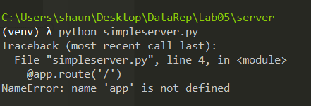

1. Run it (from the directory called server)

python a_simpleserver.py

You should get an output like this.

* Serving Flask app "a_simpleserver" (lazy loading)

* Environment: production

WARNING: This is a development server. Do not use it in a production deployment.

Use a production WSGI server instead.

* Debug mode: on

* Restarting with stat

* Debugger is active!

* Debugger PIN: 598-374-362

* Running on http://127.0.0.1:5000/ (Press CTRL+C to quit)

If you don’t it might be because the flask module needs to be loaded. Install that

pip install flask

1. Test this by opening up the browser and opening the link <http://127.0.0.1:5000/>. You should see Hello World

## Serve static pages

1. Get the app server to be able to serve static pages by adding the following line below the import flask line

app = Flask(__name__,

            static_url_path='',

            static_folder='../')

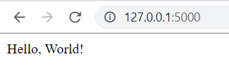

The static folder points to the directory that contains the html pages.

1. Test this code by making a static html file called index.html in the week05 directory, (ie the parent of the server directory.
2. Open the file in the browser by going to [http://127.0.0.1:5000/index.html](http://127.0.0.1:5000/index.html/). You should see your file



## Get REST server running

1. In the Server directory create a file called restserver.py. copy all the code from my file on githup and paste it into your file.

<https://github.com/andrewbeattycourseware/dataRepresentation/blob/master/code/week05-REST/server/b_restserver.py>

1. Test it: Close the simple server (ctrl-c) and run the rest server.

python restserver.py

1. You should get the same output that you got when you ran the simple server.
2. Open the browser and check you are getting the static page.

[http://127.0.0.1:5000/index.html](http://127.0.0.1:5000/index.html/)

1. Check you can get the cars

[http://127.0.0.1:5000/cars](http://127.0.0.1:5000/index.html/)

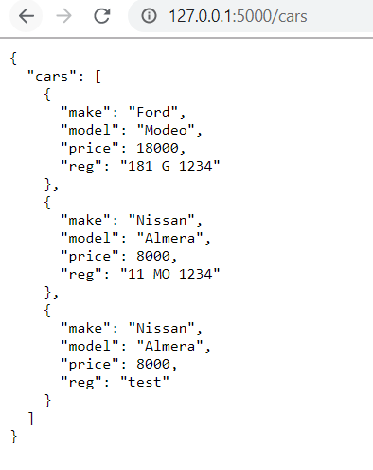

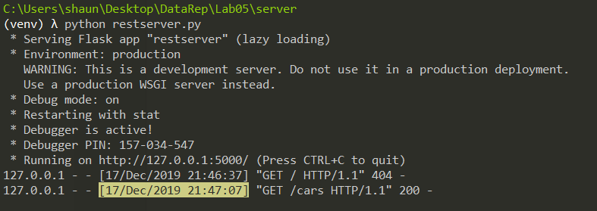

1. Check that all the REST functionality is working with the following CURL commands (in the command line.
   1. Get all

curl -i http://localhost:5000/cars

* 1. Find by id

curl -i http://localhost:5000/cars/test

* 1. Create

curl -i -H "Content-Type:application/json" -X POST -d '{"reg":"12 D 1234","make":"Fiat","model":"Punto","price":3000}' http://localhost:5000/cars

* 1. Update

curl -i -H "Content-Type:application/json" -X PUT -d '{"make":"Fiesta"}' http://localhost:5000/cars/181%20G%201234

* 1. delete

curl -i -X DELETE http://localhost:5000/cars/181%20G%201234

**A –**

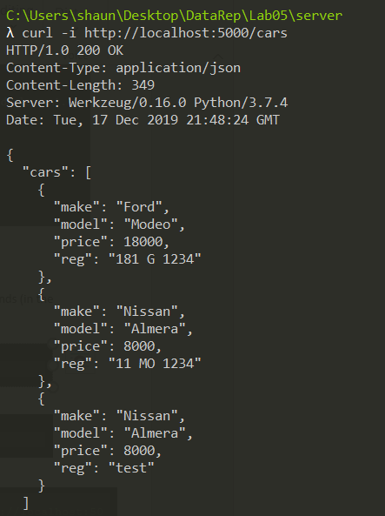

**B –**

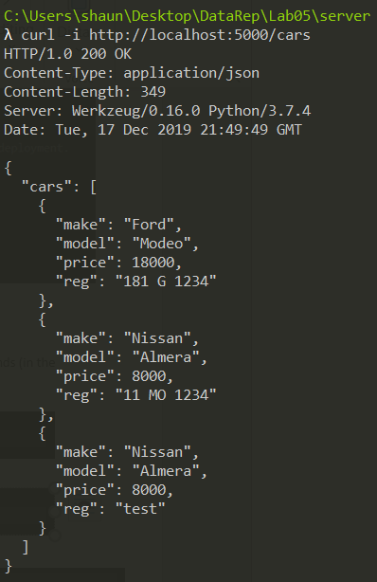

**C –**



**D –**



**E –**

